**A11Wa Compare different equations when forecasting with exponential smoothing**

There are several exponential smoothing equations we mentioned at the beginning of textbook section 11.4, namely equations (11.10-13). We will illustrate on the same data set as used in the previous textbook example that regardless of what equation we use, we get the same values. The only thing we need to pay attention to is where to place the values in the table. Figure 1 shows the example. Rows 15:55 are again hidden.

**Example 1**

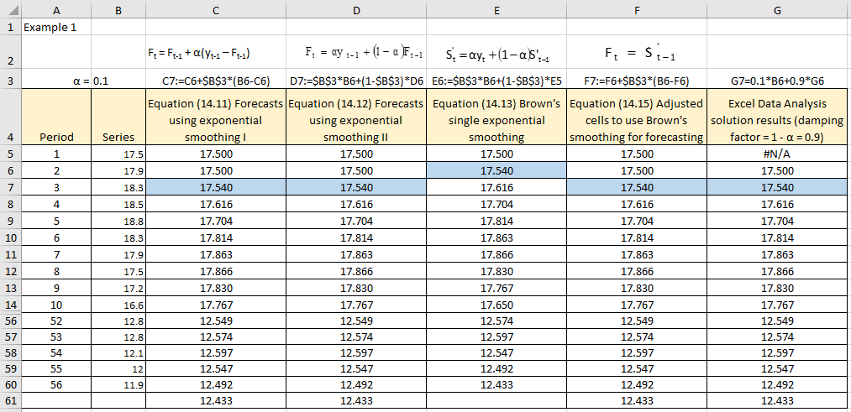

Figure 1

**Excel solution**

Period Cells A5:A60 Values

Series Cells B5:B60 Values

SES (14.11) Cell C5 Formula: =B4

Cell C6:C61 Formula: =C5+$B$3*(B5-C5)

Copy formula down C7:C61

SES (14.12) Cell D5 Formula: =B4

Cell D6:D61 Formula: = $B$3*B5+(1-$B$3)*D5

Copy formula down D7:D61

SES (14.13) Cell E5 Formula: =B4

Cell E6:E61 Formula: = $B$3*B6+(1-$B$3)*E5

Copy formula down E7:E61

SES (14.15) Cell F5 Formula: =B4

Cell F6:F61 Formula: = F5+$B$3*(B5-F5)

Copy formula down F7:F61

SES (Excel Cell G6 Formula: =B5

Data Analysis) Cell G7:G61 Formula: = 0.1*B6+0.9*G6

Formula copied down automatically G8:G61

This example just illustrates that it is irrelevant which equation we use, if we insert the values in the correct cell. Generally, the only confusion is caused by the original Brown’s exponential smoothing formula (column E in Figure 1). You must remember that this is just exponentially smoothed value. If we want it to be treated as a forecast, we need to insert it in the row bellow. The same principle as with moving averages which can be used as just a smoothing technique (either centred or placed at the end of the interval), or as forecasts (placed below the last value in the rolling period).

**Exponential smoothing forecasting as a function of forecasting error**

We will now demonstrate how to use exponential smoothing method to produce forecasts, but based on both the single (SES), double (DES) exponential smoothing and on forecasting errors. We will take textbook equation (11.17) and incorporate into it textbook equations (11.18) and (11.19) to get a new one-line equation (1), but expressed in terms of past values and past errors:

 (1)

To demonstrate this approach and validate that it produces identical values, we will use textbook Example 10.8.

**Example 2**

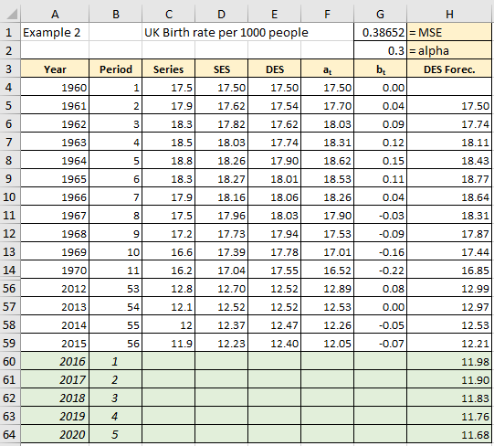

Figure 2

**Excel solution**

Year Cells A4:A60 Values

Period Cells B4:B59 Values

Series Cells C4:C59 Values

SES Cell D4 Formula: =C4

Cell D5:D59 Formula: =$F$2*C5+(1-$F$2)*D4

Copy formula down

DES Cell E4 Formula: =C4

Cell E5:E59 Formula: =$F$2*D5+(1-$F$2)*E4

Copy formula down

et Cells F4:F59 Formula: =C4-G4

Copy formula down

DES Forecasts Cell G4 and G5 Formula: =C4

Cells G6:G60 Formula: =(2*C5)-C4-(2*(1-$F$2)*F5)+((1-$F$2)^2)*F4

Copy formula down

If you compare the DES values with those in the textbook Example 11.9 (because we used the same smoothing constant alpha), you will see that from period 24 the values are identical. The reason why there are some differences before this period are the minute differences in starting condition, which have an effect on forecasts. However, in case we have longer time series, these initial differences become immaterial.